TOPIC 5.10 : GREEDY BIN PACKING FOR MINIMUM CONTAINERS
Problem Statement
Given a list of item weights and a maximum capacity for each container, determine the minimum number of containers required to load all items using a greedy approach.
The greedy approach should prioritize loading items into the current container until it is full before moving to the next container.
Test Case 1
Input:
n = 7
weights = [5, 10, 15, 20, 25, 30, 35]
max_capacity = 50
Output: 4
Test Case 2
Input:
n = 8
weights = [10, 20, 30, 40, 50, 60, 70, 80]
max_capacity = 100
Output: 6
Aim
To write a program that determines the minimum number of containers required to load all items without exceeding the maximum capacity of each container, using a greedy strategy.
Algorithm
- Start
- Sort the list of weights in descending order
- Initialize count = 0, current_capacity = 0
- For each item in weights:
  - If current_capacity + weight ≤ max_capacity, load it into the current container
  - Otherwise, start a new container, increment count, and set current_capacity = weight
- After processing all items, increment count for the last container
- Return count
- Stop
Input and Output
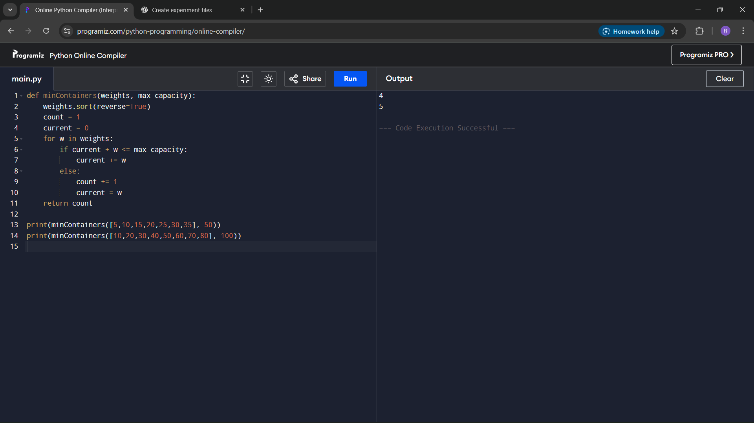
Result
The program successfully computes the minimum number of containers required to load all items using the greedy approach.
Performance Analysis
Time Complexity: O(n log n) due to sorting
Space Complexity: O(1) for counters

